**Shutterbugs Photography Club**

*Shutterbugs is a collaboration with the Morean Arts Center and Lakewood Elementary School*

***THIS CLUB WILL BE COMBINED WITH THE CAPOEIRA CLUB***

*1st-3rd Grade: 45 min in Shutterbugs, 30 min in Capoeira*

*4th and 5th Grade: 45 min in Capeoira, 30 min in Shutterbugs*

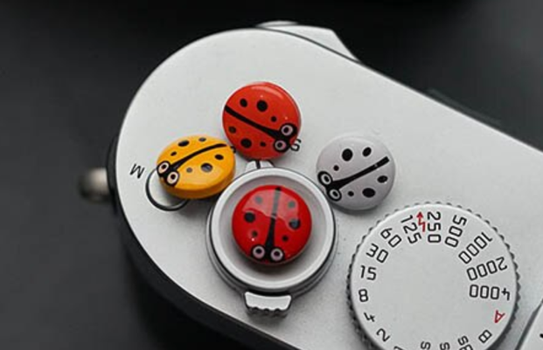

Photography is a creative and rewarding art form for children that has so many benefits.

* Builds self-esteem through new skills
* Sparks creative thinking
* Encourages self-expression
* Helps process emotions and lowers stress
* Develops motor skills and eye-hand coordination
* Builds new friendships

Each Shutterbug meeting will blend a creative and technical photo lesson that will engage the students. Several other photo-based activities will be explored, such as cyanotypes and Polaroids.

* Over the 9 weeks, students will learn parts of the camera, basic composition, some famous photographers and more. Creative projects will require teamwork and problem solving.

Each photographer will get proof prints of some images and a final professional photograph of their favorite photo. Each student will have a photo displayed at school.

* A camera will be provided for the students to use at school during the 9-weeks.

 Students who complete the Shutterbugs program will receive a Shutterbug pin!